### **Step 6. Manage Log File Sizes**

1. Run sudo nano /etc/logrotate.conf to edit the logrotate configuration file.

Solution:

~$ sudo nano /etc/logrotate.conf  
  
 Configure a log rotation scheme that backs up authentication messages to the /var/log/auth.log.

* + Add your config file edits below:

/var/log/auth.log {

weekly

rotate 7

notifempty

compress

delaycompress

missingok

}

1. [Your logrotate scheme edits here]`

Solution:

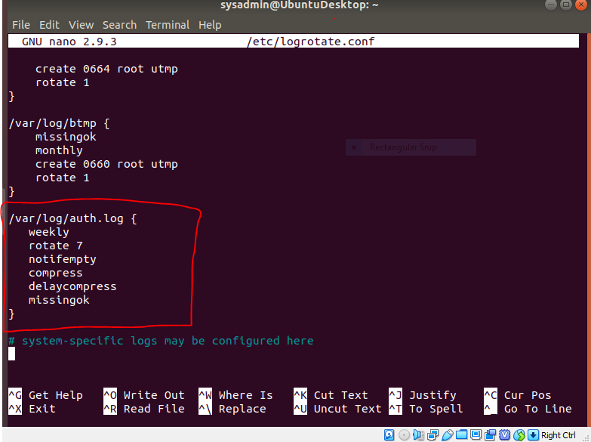

~$ sudo logrotate -vf /etc/logrotate.conf

# The above command was used to test the configuration giving a

# success as shown below.

